

Data Analytics with Power BI

**360-degree Business Analysis of Online Delivery Apps**

**The M.D.T Hindu Collage**

|  |  |
| --- | --- |
| **NM ID** | **NAME** |
| **85D814270C7944799CE49011DA715** | **BAVANI. M** |

|  |  |  |
| --- | --- | --- |
|  |  | Trainer Name |
|  |  | Master Name |
| ABSTRACT |  |  |
|  |  |  |

* This comprehensive analysis delves into the multifaceted landscape of online delivery apps, providing a 360-degree view of their business dynamics. Beginning with a thorough market analysis, the study explores market trends, growth potential, and regulatory considerations. It dissects the intricate business models, examining revenue streams, cost structures, and value propositions. Technological aspects, including app functionality and backend infrastructure, are scrutinized alongside competition analysis, differentiation strategies, and market positioning. Moreover, the analysis evaluates customer experience factors such as user interface, ordering process, and delivery quality. Challenges such as logistics management, quality control, and regulatory compliance are identified, with insights into future trends like expansion into new markets, integration of emerging technologies, and sustainability initiatives. This abstract encapsulates a comprehensive examination of online delivery apps, offering stakeholders invaluable insights for strategic decision-making and innovation within the industry

INDEX

|  |  |  |
| --- | --- | --- |
| **Sl.No** | **Table of Contents** | **Page No.** |
| 1 | Chapter1: INTRODUCTION | 3 |
| 2 | Chapter2: Services and tools Required | 9 |
| 3 | Chapter3: project Architecture | 11 |
| 4 | Chapter4: Model and Result | 13 |
| 5 | Future scope | 17 |
| 6 | Opportunities of ZOMATO | 20 |
| 7 | Conclusion | 23 |
| 8 | References | 24 |
| 9 | Link | 24 |

**CHAPTER 1**

**INTRODUCTION**

* In today’s digital age, online delivery apps have revolutionized the way consumers access goods and services. With the convenience of ordering from the comfort of their homes, consumers are increasingly relying on these platforms for their daily needs. This report aims to provide a comprehensive analysis of the online delivery app industry using Power BI, a powerful business intelligence tool. By leveraging data visualization and analytics, we will delve into various aspects of the business, including customer behavior, market trends, operational efficiency, and financial performance.

**Key Objectives:**

* Understand Customer Behavior: Analyze customer preferences, ordering patterns, and demographics to tailor marketing strategies and improve customer experience.
* Market Trends Analysis: Identify emerging trends, competitive landscape, and market opportunities to stay ahead of the curve and adapt to changing consumer demands.
* Operational Efficiency Assessment: Evaluate delivery time, order fulfillment rate, and driver performance to streamline operations and enhance efficiency.
* Financial Performance Evaluation: Monitor revenue, profitability, and cost metrics to optimize pricing strategies and maximize profitability.

**Data Sources:**

* Transactional data from online delivery app platforms.
* Customer feedback and ratings.
* Market research reports and industry benchmarks.
* Operational metrics from delivery logistics systems.
* Financial data from accounting records and payment gateways.

**Methodology:**

* Data Extraction: Collect relevant data from various sources, ensuring data integrity and consistency.
* Data Preparation: Cleanse, transform, and integrate the data for analysis, addressing any inconsistencies or missing values.
* Data Modeling: Create a data model that reflects the relationships between different entities, such as customers, orders, products, and drivers.
* Visualization and Analysis: Utilize Power BI to create interactive dashboards and reports, allowing stakeholders to explore key metrics and trends visually.
* Insights Generation: Extract actionable insights from the data analysis to drive strategic decision-making and operational improvements.

**Key Deliverables:**

* Customer Segmentation Analysis: Identify different customer segments based on their behavior, preferences, and demographics.
* Market Share and Competitive Analysis: Compare market share, customer satisfaction, and service quality against competitors.
* Operational Efficiency Dashboard: Monitor key operational metrics such as delivery time, order accuracy, and driver performance in real-time.
* Financial Performance Dashboard: Track revenue, profit margins, and cost breakdowns to assess the overall financial health of the business.
* Predictive Analytics: Forecast future demand, revenue, and customer churn using advanced predictive modeling techniques.
  1. **Proposed Solution**

**Data Integration and Preparation:**

* data from various sources including transactional databases, customer feedback systems, market research reports, and operational metrics.

Cleanse and transform the data to ensure consistency and accuracy.

* Integrate the data into a unified data model, establishing relationships between different entities such as customers, orders, products, and drivers.

**Dashboard Development:**

* Develop interactive dashboards using Power BI to visualize key metrics and trends.
* Customize dashboards to cater to different stakeholders such as executives, marketing teams, and operations managers.
* Include slicers, filters, and drill-down capabilities to enable users to explore data at different levels of granularity.

**Customer Behavior Analysis:**

* Segment customers based on demographic information, ordering frequency, order value, and product preferences.
* Analyze customer retention rates, churn patterns, and lifetime value to identify opportunities for customer engagement and loyalty programs.
* Incorporate sentiment analysis of customer feedback to understand satisfaction levels and areas for improvement.

**Market Trends and Competitive Analysis:**

* Monitor market share trends, competitor performance, and customer satisfaction ratings.
* Utilize geographic heat maps to visualize market penetration and identify underserved areas for expansion.
* Benchmark key performance indicators against industry standards and competitors to gauge relative performance.

**Operational Efficiency Assessment:**

* Track delivery time, order fulfillment rate, and driver performance metrics in real-time.
* Identify bottlenecks in the delivery process and optimize routing algorithms to improve efficiency.
* Implement predictive analytics models to forecast demand and allocate resources effectively.

**Financial Performance Evaluation:**

* Analyze revenue streams, profit margins, and cost breakdowns to assess financial health.
* Generate profitability reports by product category, delivery zone, and customer segment.
* Identify cost-saving opportunities and revenue optimization strategies to improve overall profitability.

**Predictive Analytics and Forecasting:**

* Develop predictive models to forecast demand, revenue, and customer churn.
* Incorporate external factors such as weather patterns, seasonal trends, and economic indicators into forecasting models.
* Evaluate the accuracy of forecasts and continuously refine models based on actual performance data.

**Actionable Insights and Recommendations:**

* Translate data analysis findings into actionable insights and recommendations for strategic decision-making.Collaborate with cross-functional teams to implement recommended initiatives and track their impact over time.
* Continuously monitor performance metrics and iterate on analysis methodologies to drive continuous improvement.
* By implementing this proposed solution, online delivery apps can gain a comprehensive understanding of their business performance and leverage data-driven insights to drive growth, improve operational efficiency, and stay competitive in the dynamic marketplace.
  1. **Feature**
* **Drill-Down Capabilities:** Enable users to drill down into specific data points to uncover underlying trends and patterns, facilitating deeper analysis.
* Customized Visualizations: Tailor visualizations to meet specific business requirements and preferences, including custom color schemes, labeling, and formatting options.
* **Real-Time Data Updates:** Utilize Power BI’s real-time data refresh capabilities to ensure that dashboards always reflect the latest information, allowing for timely decision-making.
* **Mobile Accessibility:** Access dashboards on-the-go via Power BI mobile apps, enabling users to stay informed and make data-driven decisions from anywhere.
  1. **Advantages**
* **Sales Performance:** Utilize Power BI to track sales trends over time, identify peak hours, popular items, and revenue generated per order. Visualize this data through interactive dashboards to gain insights into customer behavior and preferences.
* **Customer Segmentation:** Segment customers based on demographics, order frequency, and order value. Understand which customer segments contribute the most to revenue and tailor marketing strategies accordingly.
* **Market Basket Analysis:** Analyze the association between different items purchased together to optimize product offerings and promotions. Identify cross-selling and upselling opportunities to increase average order value.
* **Operational Efficiency:** Monitor delivery times, driver performance, and order fulfillment rates. Identify bottlenecks in the delivery process and optimize routes for faster delivery times and improved customer satisfaction.
  1. **Scope**
* A comprehensive 360-degree business analysis of online delivery apps utilizing Power BI encompasses a thorough examination of multiple facets crucial for success in the digital delivery landscape. This analysis delves into sales and revenue dynamics, dissecting trends and regional variations to inform strategic decisions. It extends to customer segmentation, behavior patterns, and retention rates, fostering targeted marketing strategies and enhancing customer experience. Operational efficiency is scrutinized, optimizing delivery times, driver performance, and inventory management for streamlined operations. Market trends and competitor analysis provide insights for market positioning and expansion opportunities. Financial performance evaluation, including profitability and cost analysis, ensures sustainable growth. Additionally, leveraging predictive analytics enables forecasting of demand and trends, empowering proactive decision-making. By harnessing Power BI’s capabilities to consolidate data and generate interactive dashboards, stakeholders gain actionable insights, driving continual improvement and competitiveness in the online delivery ecosystem.

**CHAPTER 2**

**SERVICES AND TOOLS REQUIRED**

**2.1 Services Used**

* **Data Collection and Storage Services**: Banks need to collect and store customer data in real-time. This could be achieved through services like Azure Data Factory, Azure Event Hubs, or AWS Kinesis for real-time data collection, and Azure SQL Database or AWS RDS for data storage.
* **Data Processing Services**: Services like Azure Stream Analytics or AWS Kinesis Data Analytics can be used to process the real-time data.
* **Machine Learning Services**: Azure Machine Learning or AWS SageMaker can be used to build predictive models based on historical data.

**2.2 Tools and Software used**

**Tools**:

* **PowerBI**: The main tool for this project is PowerBI, which will be used to create interactive dashboards for real-time data visualization.
* **Power Query**: This is a data connection technology that enables you to discover, connect, combine, and refine data across a wide variety of sources.

**Software Requirements**:

* **Power BI Desktop**: This is a Windows application that you can use to create reports and publish them to PowerBI.
* **PowerBI Service**: This is an online SaaS (Software as a Service) service that you use to publish reports, create new dashboards, and share insights.
* **PowerBI Mobile**: This is a mobile application that you can use to access your reports and dashboards on the go.

**CHAPTER 3**

**PROJECT ARCHITECTURE**

**3.1 Architecture**

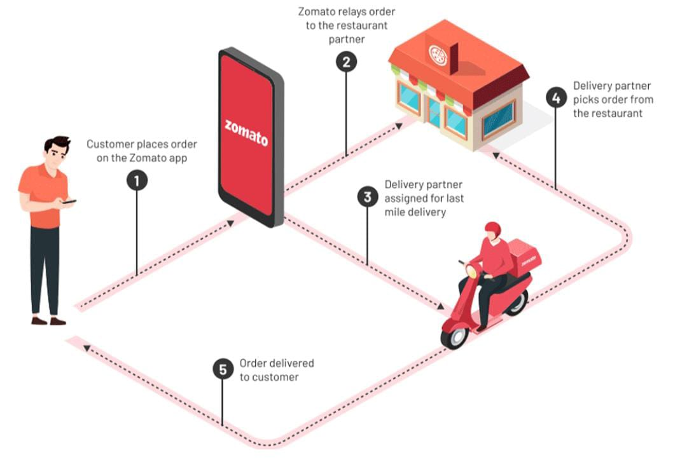

Here’s a high-level architecture for the project:

**Data Collection and Integration:**

* Gather data from various sources including transactional databases, customer reviews, app usage logs, delivery performance metrics, etc.
* Integrate data from different sources into a central data repository, such as a data warehouse or data lake.

**Data Modeling:**

* Design a data model that represents the relationships between different entities in the online delivery ecosystem (e.g., customers, orders, delivery personnel, restaurants).
* Define measures and dimensions necessary for analysis, such as order volume, delivery time, customer satisfaction scores, etc.

**Data Transformation and Cleansing:**

* Cleanse and transform raw data to ensure consistency and accuracy.
* Handle missing or erroneous data through techniques like imputation or removal.

**Dashboard and Report Design:**

* Use Power BI to design interactive dashboards and reports that provide insights into various aspects of the online delivery business.
* Include visualizations such as charts, graphs, maps, and KPI cards to present key metrics and trends effectively.

**Advanced Analytics:**

* Implement advanced analytics techniques such as predictive modeling, sentiment analysis, and clustering to gain deeper insights into customer behavior, market trends, and operational efficiency.
* Utilize Power BI’s integration with R or Python for advanced analytics if needed.

**Performance Optimization:**

* Optimize data queries and dashboard performance to ensure fast and responsive user experience, especially when dealing with large volumes of data.

**Security and Governance:**

* Implement security measures to protect sensitive data and ensure compliance with regulations such as GDPR or HIPAA.
* Establish governance policies for data access, sharing, and refresh schedules.

**Deployment and Maintenance:**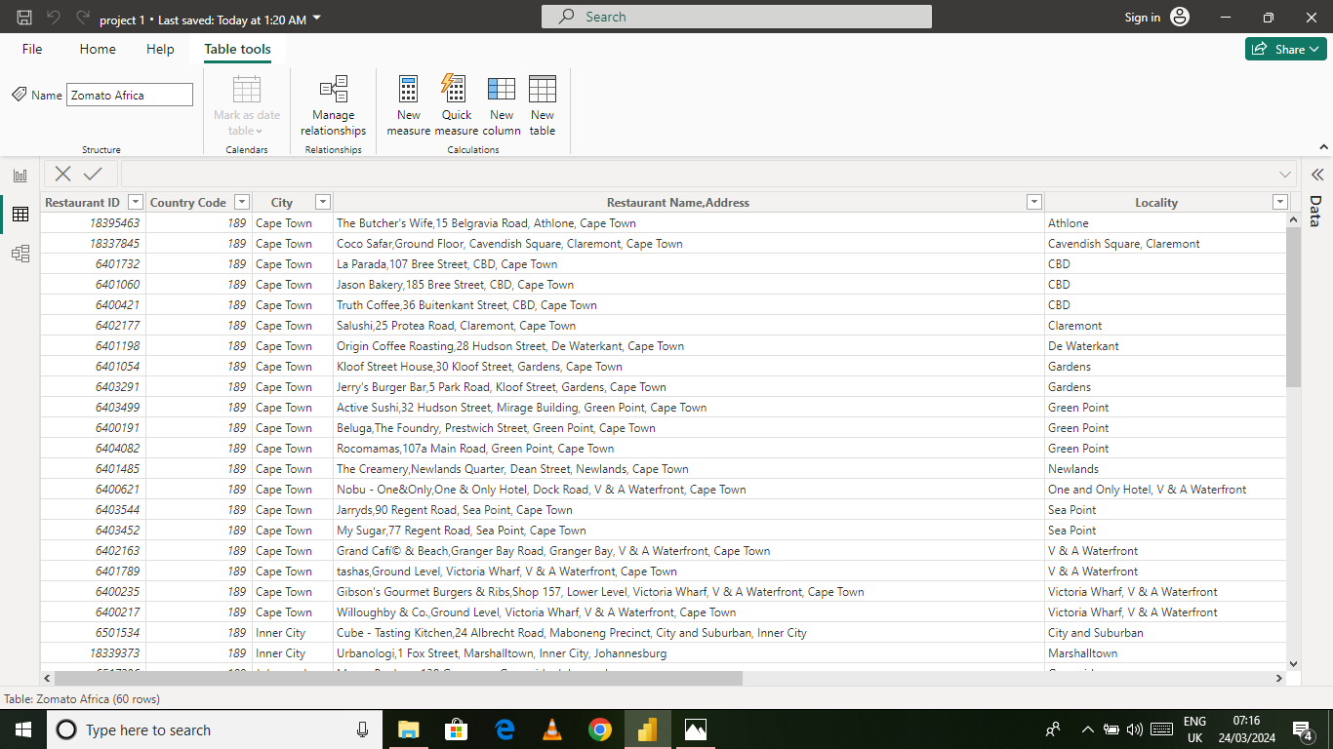

Deploy the Power BI solution to a suitable environment (e.g., Power BI Service, on-premises server) for consumption by stakeholders.

Regularly monitor and maintain the solution to accommodate changes in data sources, business requirements, or user feedback.

By following this project architecture, you can create a comprehensive analysis of online delivery apps using Power BI, enabling stakeholders to make data-driven decisions and drive business growth.

CHAPTER 4

**Modeling** **And** **Result**

**Manage Relationship:**

**The “ZOMATO Global” file will be used as the main connector as it contains most key identifier which can be relates the 3 data file together.**

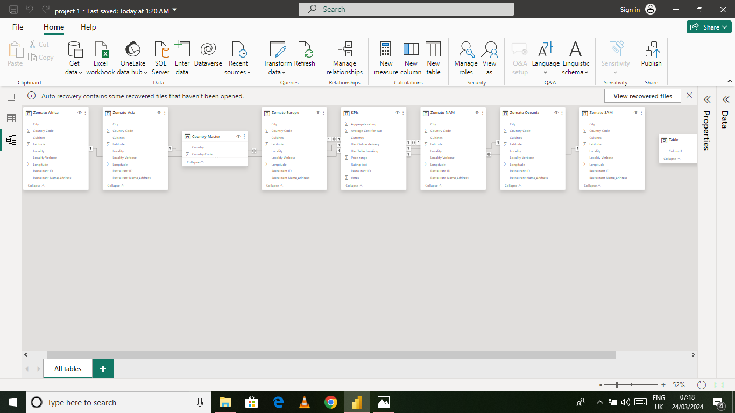



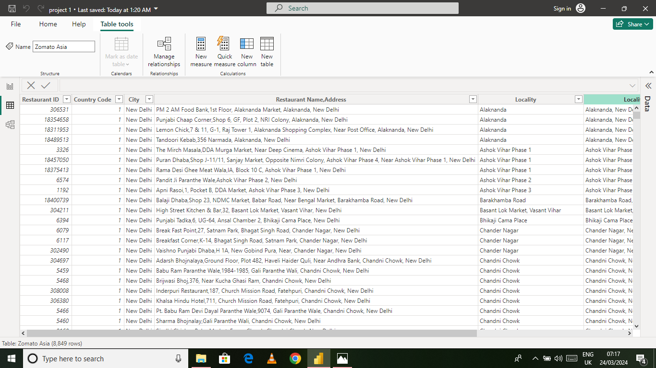

**Dashboard**

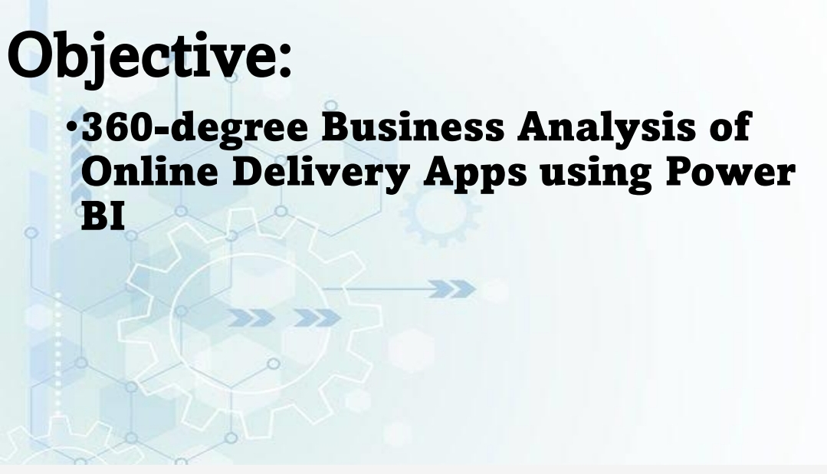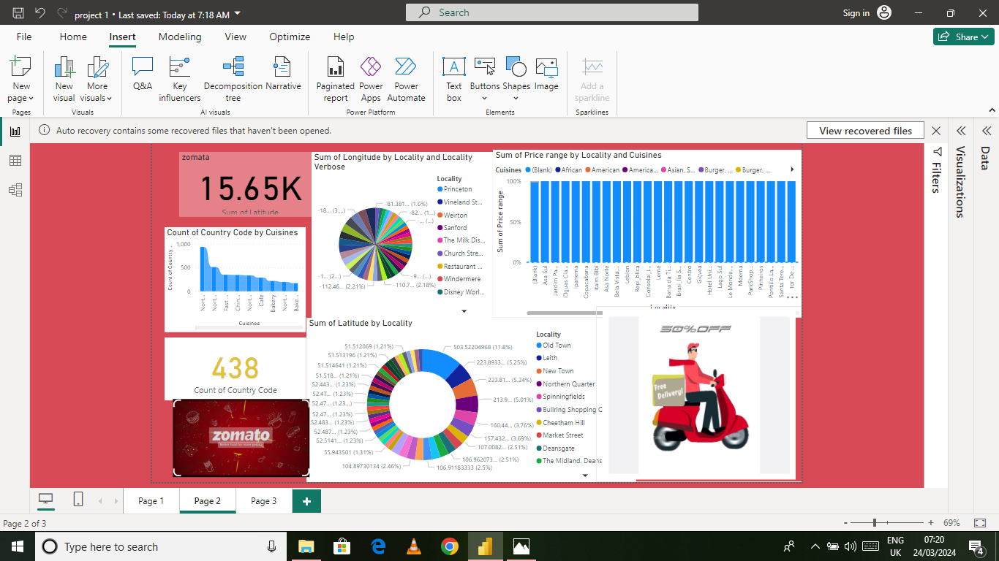

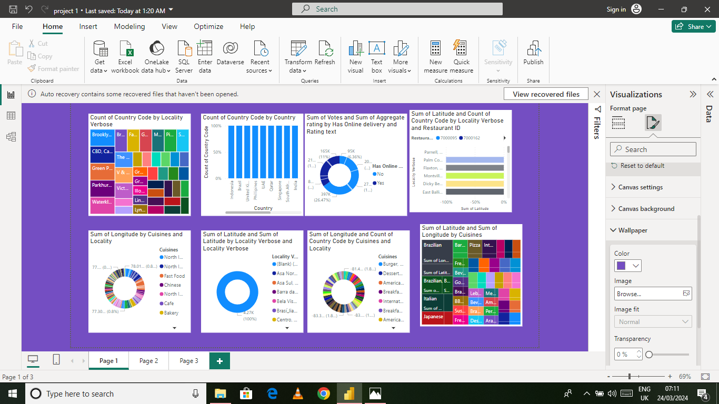

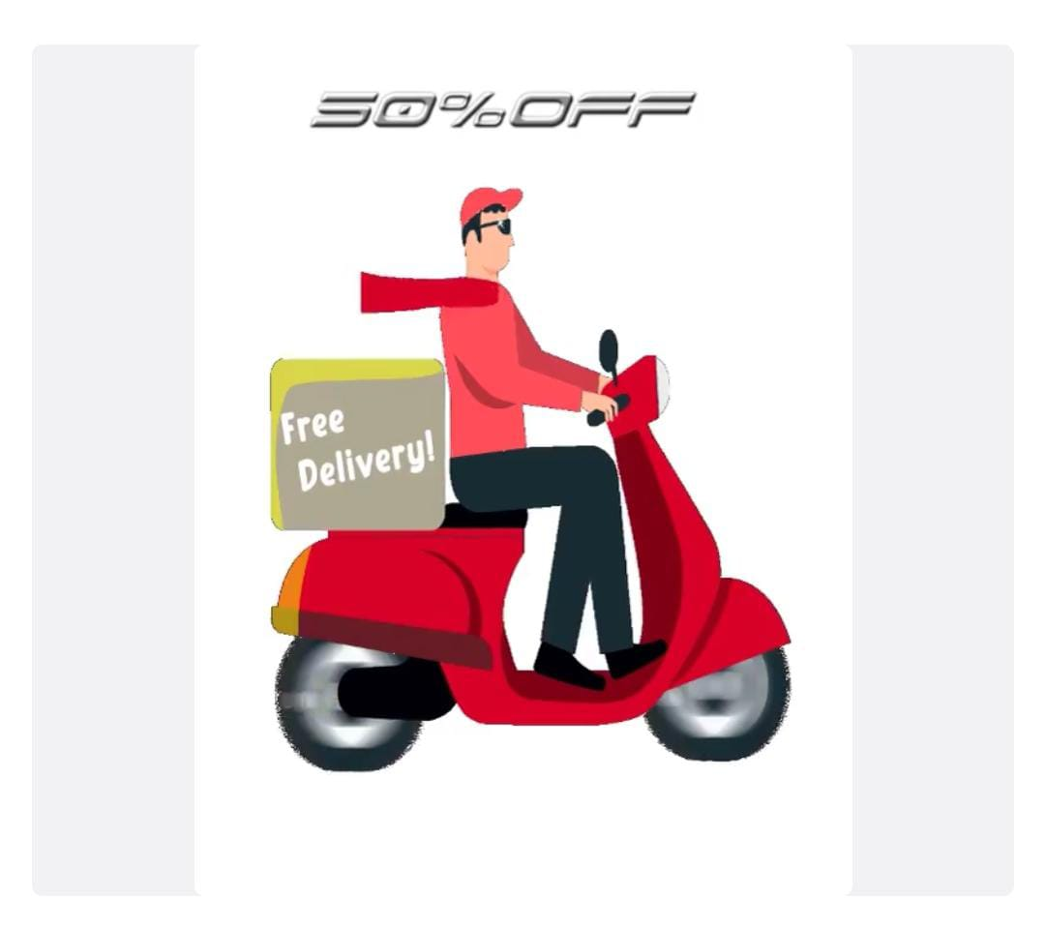

The 360-

**FUTURE SCOPE**

The future scope of this project is vast. With the advent of advanced analytics and machine learning, Power BI can be leveraged to predict future trends based on historical data. Integrating these predictive analytics into the project could enable the bank to anticipate customer needs and proactively offer solutions. Furthermore, Power BI’s capability to integrate with various data sources opens the possibility of incorporating more diverse datasets for a more holistic view of customers. As data privacy and security become increasingly important, future iterations of this project should focus on implementing robust data governance strategies. This would ensure the secure handling of sensitive customer data while complying with data protection regulations. Additionally, the project could explore the integration of real-time data streams to provide even more timely and relevant insights. This could potentially transform the way banks interact with their customers, leading to improved customer satisfaction and loyalty.

Overall, the 360-degree business analytics using online delivery in power BI holds immense potential for innovation and growth. By Staying abreast of emerging technologies and evolving customer demands business can leverage power BI to drive efficiency, optimize operational, and deliver superior online delivery experiences.

* Opportunities of ‘ZOMATO’



EXPANSION:

* Expansion of their food delivery services to smaller towns and cities in INDIA.

COLLABORATION:

* Expansion of their food delivery services to smaller towns and cities in India and leveraging its technology and data to offer targeted and personalized recommendations to customers.

TECHNOLOGY;

* Leveraging its technology and data to offer TARGETED

**STRENGTHS OF ‘ZOMATO’**



* Zomato has a wider reach in terms of the number of cities and towns it operates in, compared to Swiggy.
* Zomato also has a more robust online food ordering system which is more user friendly and has more payment options in all platforms.
* Zomato also has a larger number of restaurants on its platform and more divers options in terms of cuisines.
* Zomato also has a larger number of delivery fleet and has a more efficient delivery system which allows faster delivery times.

Weakness of ‘ZOMATO’



* Zomato presence may be limited in smaller cities and towns in India, which can limit its reach and market share.
* Zomato delivery fleet and large number of restaurants on its platform may lead to high operational costs.
* The brand value of Zomato is considered slightly low compared to its competitor SWIGGY.

**CONCLUSION**

* degree business analysis conducted using Power BI for online delivery apps offers valuable insights essential for strategic decision-making and operational enhancement. Through detailed examination of market penetration, user behavior, revenue generation, performance metrics, competitive analysis, and cost management, businesses can gain a comprehensive understanding of their operations. By leveraging this data-driven approach, companies can optimize their marketing efforts, improve user experience, identify revenue streams, enhance operational efficiency, and stay competitive in the market. Moreover, the integration of predictive analytics enables proactive measures for demand forecasting, inventory management, and personalized customer experiences. Overall, Power BI facilitates informed decision-making, driving sustainable growth and success in the dynamic landscape of online delivery services.

***REFERENCES***

<https://www.youtube.com/watch?v=ZgzGqoq3Xuc>

**LINK**